UNIVERSITY INSTITUTE OF COMPUTING

PROJECT REPORT ON
MAZE BUILDER AND SOLVER

Program Name: BCA(DATA SCIENCE)
Subject Name/Code: Data Structures(24CAH-201)

Submitted by: Submitted to:
Name: Praveen Kumar Name: Ms. Suchi Mam
UID: 24BCD10004 Designation: Assistant Prof.
Section: 24BCD-1/A

ABSTRACT

Introduction:
This C++-based Maze Solver application enables users to input a custom 5x5 maze and find a path from a start point ('S') to an endpoint ('E') using the stack data structure (STL stack). The maze is represented with '0' for open paths, '1' for walls, 'S' for the start, and 'E' for the end. The program employs object-oriented programming concepts by encapsulating maze operations within a class and utilizes a stack-based backtracking algorithm to explore and trace possible paths, marking the correct route with '*'. Users can define their own maze, display it, and initiate the solving process through a menu-driven interface. The application emphasizes OOP principles, STL containers, and backtracking algorithms, providing an interactive and educational experience for understanding data structures and algorithms in C++.

Technique:
The application is developed using C++ with a focus on object-oriented programming and efficient use of STL data structures. It employs the following techniques:
- Stack Data Structure: The program uses the STL stack container to store maze coordinates and perform backtracking when a dead end is encountered, following the LIFO (Last In, First Out) principle.
- Object-Oriented Design: The maze-solving process is encapsulated within a class, promoting modularity, code reusability, and abstraction for better structure and clarity.
- Dynamic Path Exploration: The algorithm dynamically explores valid paths using stack-based backtracking, avoiding fixed-size arrays or manual memory allocation.
- User Input Handling: The program allows users to input a 5x5 maze, ensuring the presence of exactly one 'S' (start) and one 'E' (end) before beginning the solving process.

System Configuration:

• Operating System: Windows 10 / Linux / macOS (Intel or Apple Silicon)
• Processor: Intel Core i3 (minimum); Core i5 or higher recommended; Apple M1 chip (minimum) or higher
• RAM: 4 GB (minimum); 8 GB or more recommended for smoother execution
• Development Environment: Any C++ IDE such as Code::Blocks, Dev C++, Visual Studio, or Visual Studio Code with a g++ compiler (MinGW or GCC)

SUMMARY
Input and Menu System:
The program begins with a menu-driven interface that allows the user to select from the following options:
• 1: Input and Solve Maze
• 2: Display Current Maze
• 0: Exit

For Input and Solve Maze:
• The user enters a 5×5 maze row by row, providing 5 characters per row (e.g., "11011").
• Valid characters include:
- '0' → Path
- '1' → Wall
- 'S' → Start
- 'E' → End
• The program validates the maze to ensure exactly one 'S' and one 'E' are present.
Example Input:
Row 1: 11111
Row 2: 1S011
Row 3: 10001
Row 4: 11E11
Row 5: 11111
After validation, the solver uses a stack-based backtracking algorithm to find the path between 'S' and 'E'.

For Display Current Maze:
The program displays the maze currently in memory—either the original user input or the solved maze (with the path marked).

Internal Process:
- The user inputs the maze, which is stored in a 2D array within a class.
- Validation ensures there is only one 'S' and one 'E'.
- An STL stack stores the coordinates (row, column) during traversal.
- The solver starts at 'S' and pushes it onto the stack.
- While the stack is not empty:
  - Pop the top element.
  - Check if it is 'E'; if yes, mark the successful path.
  - Explore four directions — up, right, down, left.
  - If a move is valid (inside bounds, not a wall, and not visited), push it onto the stack and mark as visited.
- If the stack becomes empty before reaching 'E', display "No solution found."
- If a path is found, the program displays the maze with the correct route marked by '*'.

Main Menu
The program provides a simple menu-driven interface for user interaction:
1: Input and Solve Maze
2: Display Current Maze
0: Exit

For Input and Solve Maze:
When the user selects Option 1, the program prompts for maze input as follows:
Prompt:
Enter row 1 (5 chars: 0, 1, S, E):
Example Input:
Row 1: 11111
Row 2: 1S011
Row 3: 10001
Row 4: 11E11
Row 5: 11111
After input validation, the solver uses an STL stack-based backtracking algorithm to find a path between 'S' and 'E'.
Example Output (with solution path marked by '*'):
1 1 1 1 1
1 S * 1 1
1 * * * 1
1 1 E 1 1
1 1 1 1 1
If no valid path exists, the program displays:
No solution found.

For Display Current Maze:
When the user selects Option 2, the program displays the maze currently stored in memory—either the original user input or the solved version.
Example Output (before solving):
1 1 1 1 1
1 S 0 1 1
1 0 0 0 1
1 1 E 1 1
1 1 1 1 1

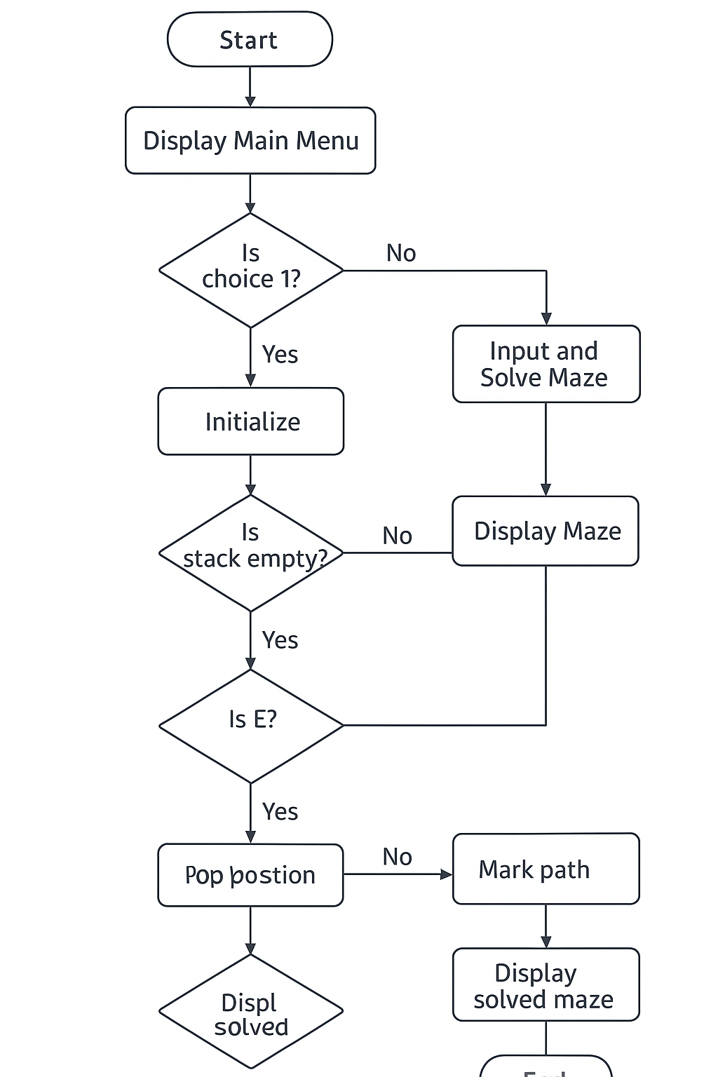

Code
#include <iostream>
#include <stack>
#include <utility>
using namespace std;

class MazeSolver {
private:
char maze[5][5];
bool visited[5][5];
pair<int, int> start, end;

bool isValid(int x, int y) {
return (x >= 0 && x < 5 && y >= 0 && y < 5 && maze[x][y] != '1' && !visited[x][y]);
}

public:
MazeSolver() {
for (int i = 0; i < 5; i++)
for (int j = 0; j < 5; j++) {
maze[i][j] = '0';
visited[i][j] = false;
}
}

void inputMaze() {
cout << "\nEnter your 5x5 maze row by row (use 0=path, 1=wall, S=start, E=end):\n";
int sCount = 0, eCount = 0;
for (int i = 0; i < 5; i++) {
cout << "Row " << i + 1 << ": ";
for (int j = 0; j < 5; j++) {
cin >> maze[i][j];
visited[i][j] = false;
if (maze[i][j] == 'S') {
start = {i, j};
sCount++;
}
if (maze[i][j] == 'E') {
end = {i, j};
eCount++;
}
}
}
if (sCount != 1 || eCount != 1)
cout << "\n⚠️ Error: Maze must contain exactly one 'S' and one 'E'.\n";
else
cout << "\n✅ Maze input successfully!\n";
}

void displayMaze() {
cout << "\nCurrent Maze:\n";
for (int i = 0; i < 5; i++) {
for (int j = 0; j < 5; j++)
cout << maze[i][j] << " ";
cout << endl;
}
}

void solveMaze() {
stack<pair<int, int>> s;
s.push(start);
visited[start.first][start.second] = true;
int dx[4] = {-1, 0, 1, 0};
int dy[4] = {0, 1, 0, -1};
bool pathFound = false;
while (!s.empty()) {
pair<int, int> current = s.top();
int x = current.first;
int y = current.second;
if (maze[x][y] == 'E') {
pathFound = true;
break;
}
bool moved = false;
for (int i = 0; i < 4; i++) {
int nx = x + dx[i];
int ny = y + dy[i];
if (isValid(nx, ny)) {
visited[nx][ny] = true;
s.push({nx, ny});
moved = true;
break;
}
}
if (!moved)
s.pop();
}
if (pathFound) {
cout << "\n✅ Path Found! Displaying solved maze:\n";
while (!s.empty()) {
pair<int, int> p = s.top();
s.pop();
if (maze[p.first][p.second] != 'S' && maze[p.first][p.second] != 'E')
maze[p.first][p.second] = '*';
}
displayMaze();
} else
cout << "\n❌ No solution found.\n";
}
};

int main() {
MazeSolver solver;
int choice;
do {
cout << "\n========= MAZE BUILDER AND SOLVER =========\n";
cout << "1. Input and Solve Maze\n";
cout << "2. Display Current Maze\n";
cout << "0. Exit\n";
cout << "Enter your choice: ";
cin >> choice;
switch (choice) {
case 1:
solver.inputMaze();
solver.solveMaze();
break;
case 2:
solver.displayMaze();
break;
case 0:
cout << "\nExiting program... Goodbye!\n";
break;
default:
cout << "\nInvalid choice. Try again.\n";
}
} while (choice != 0);
return 0;
}

Output:

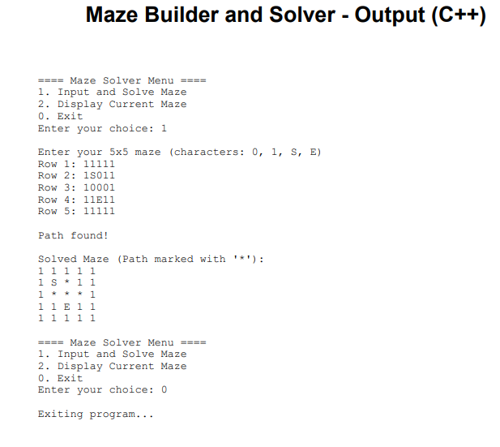
GitHub Link: https://github.com/proficient-12/Maze-Builder-and-Solver-C-

